# Symantec

## 03 excel

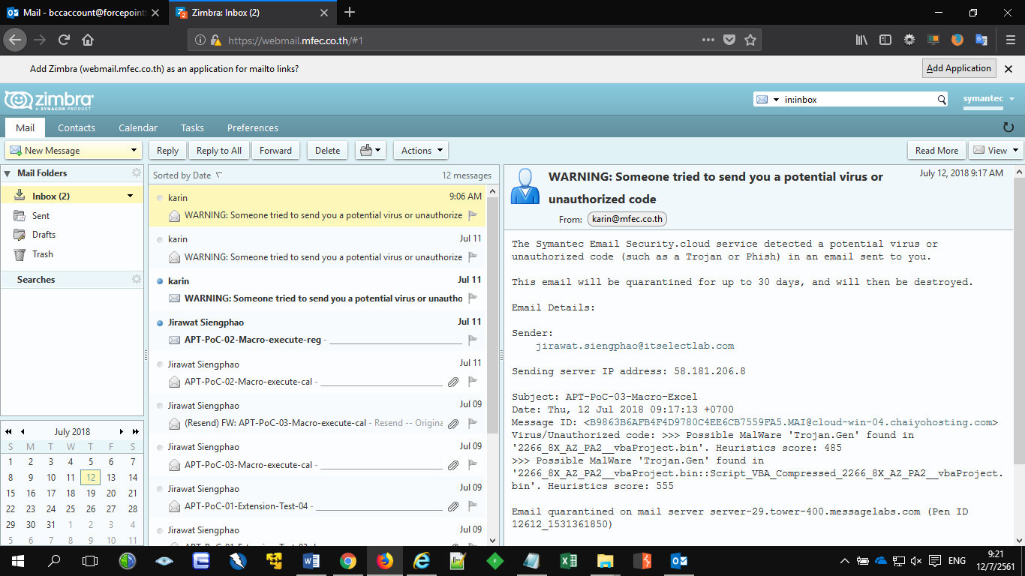

## 04 Known

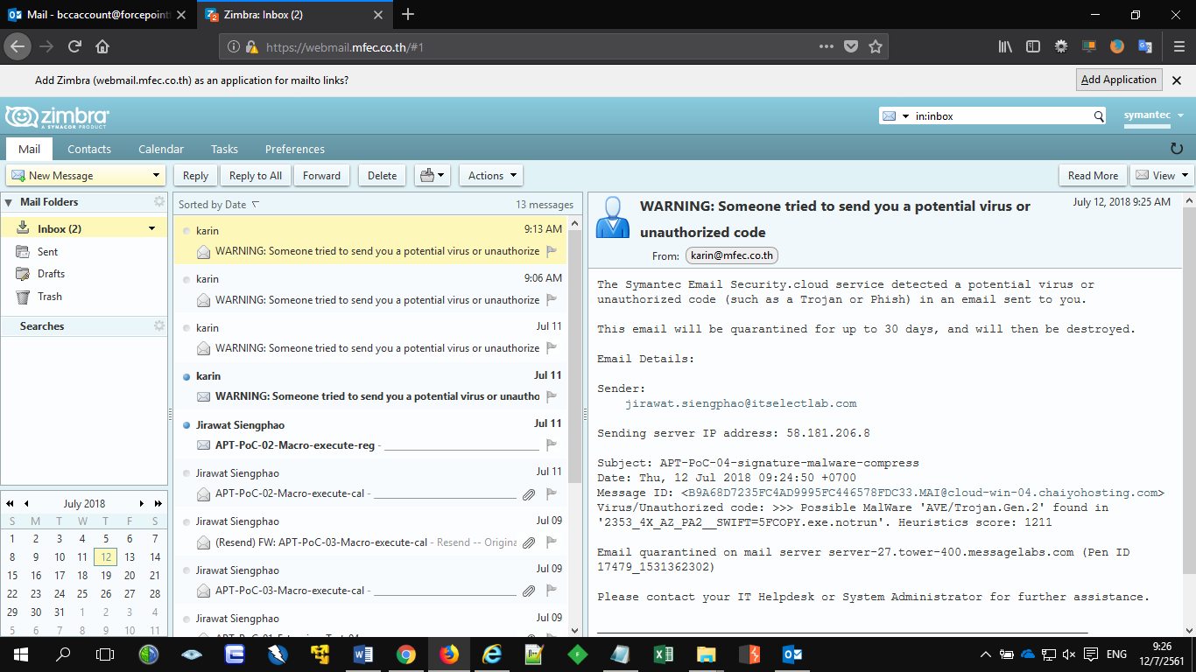

## 05 easy

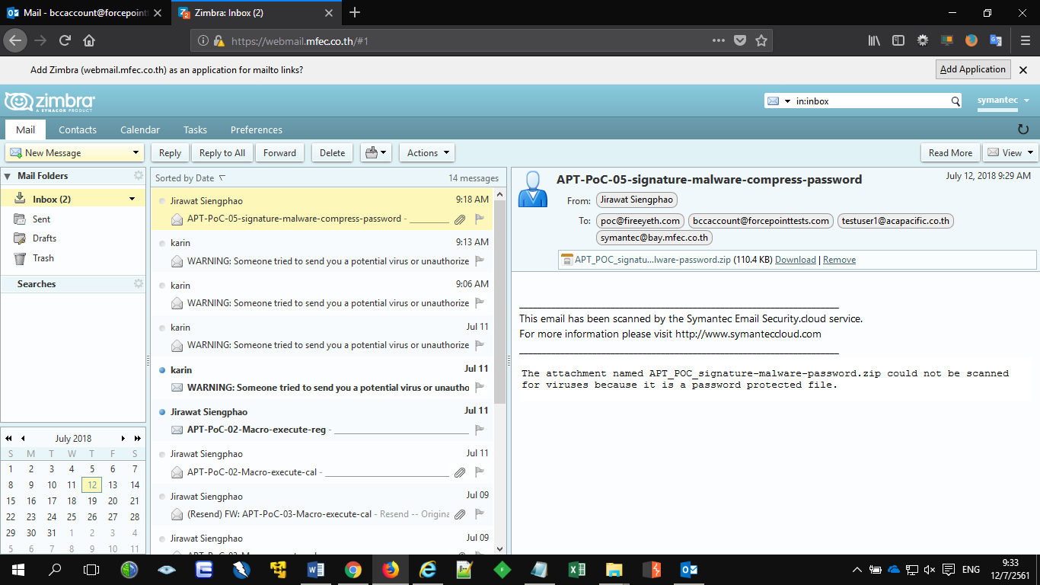

## 05 hard

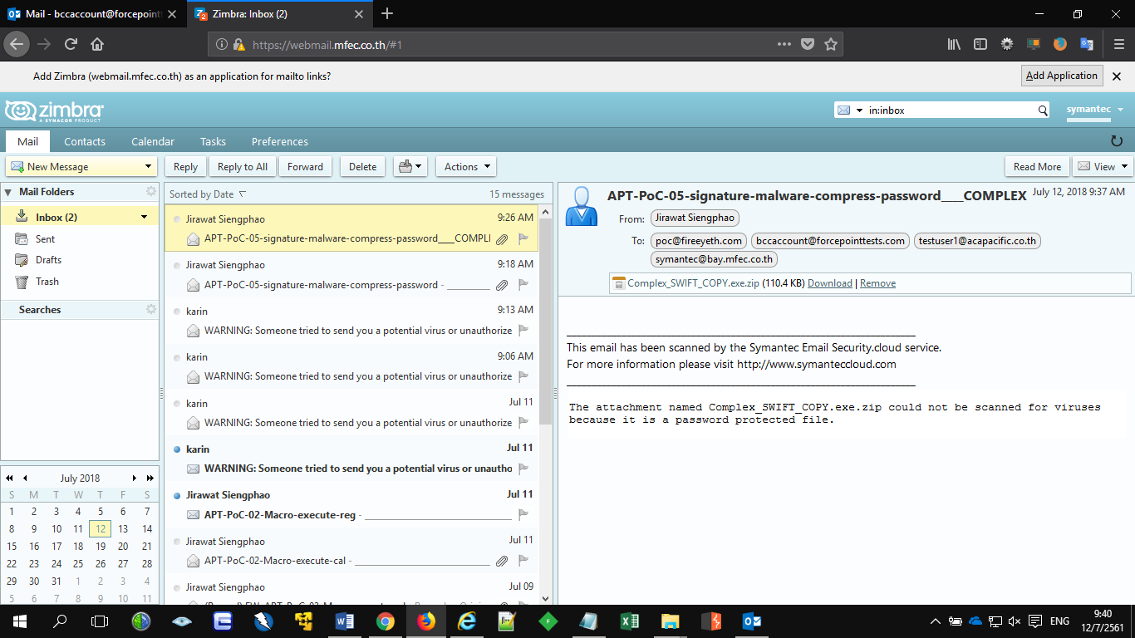

## 06 Clicktime

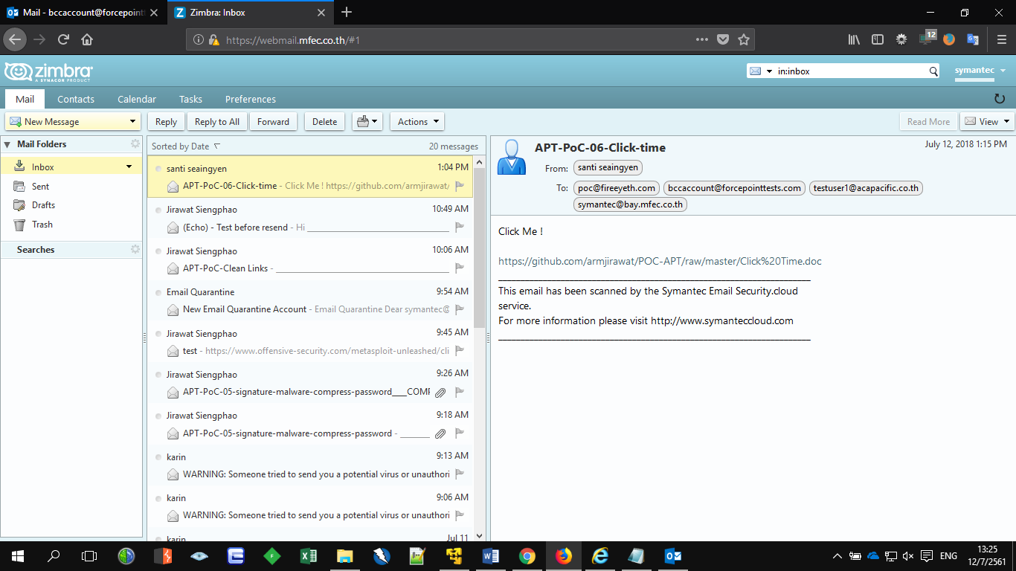

## 07 docx

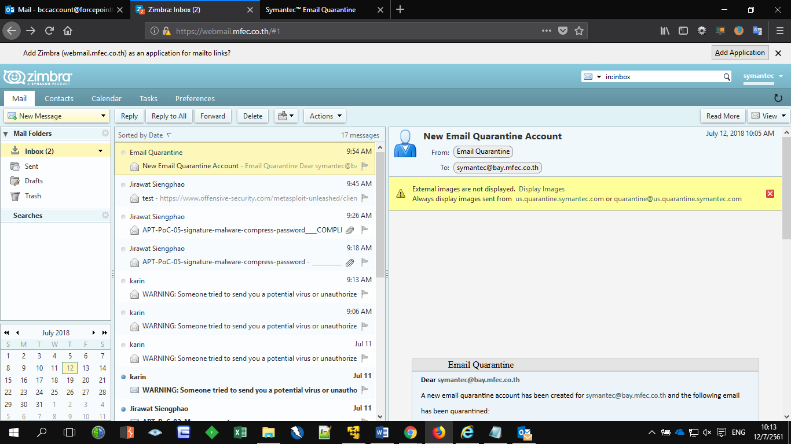

Login to Symantec to see quarantine email

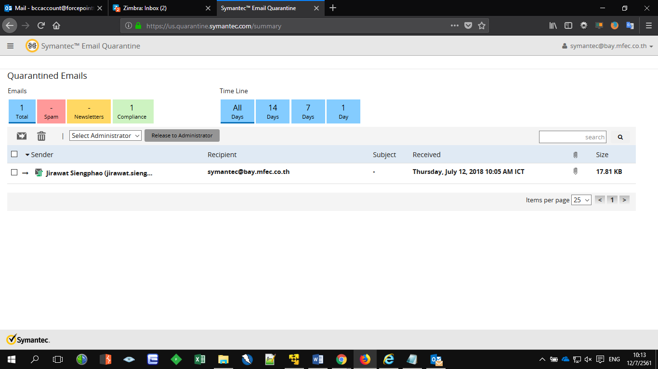

# Cisco

## 02 calc

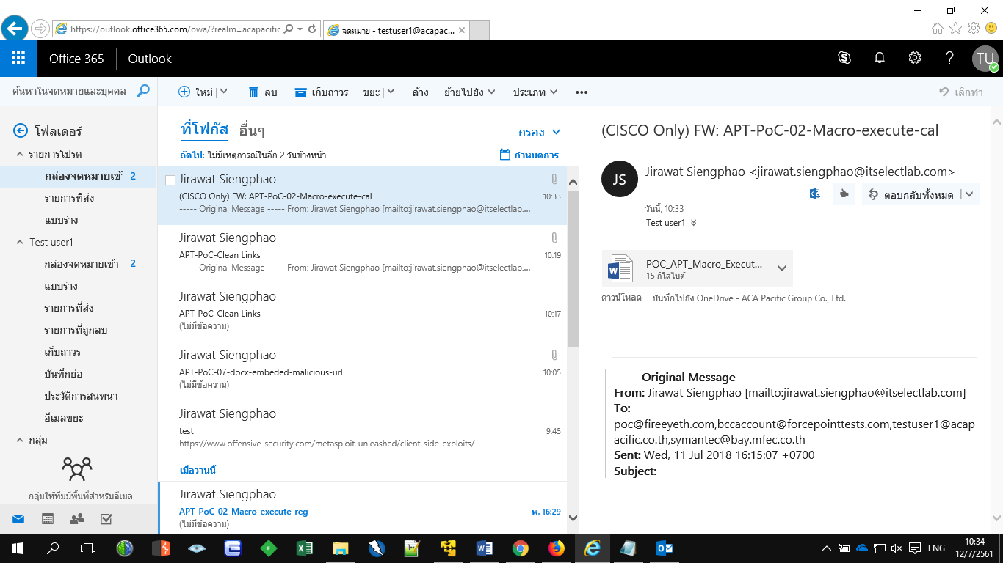

## 02 reg

Blocked

## 03 excel

Blocked

## 04 Known

Blocked

## 05 easy

Pending

## 05 hard

Pending

## 06 Clicktime

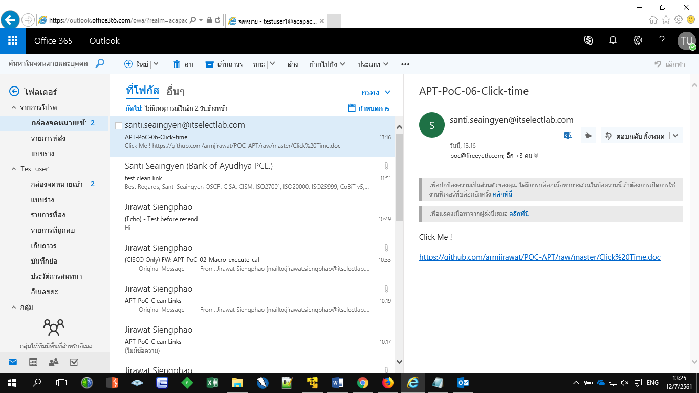

## 07 docx

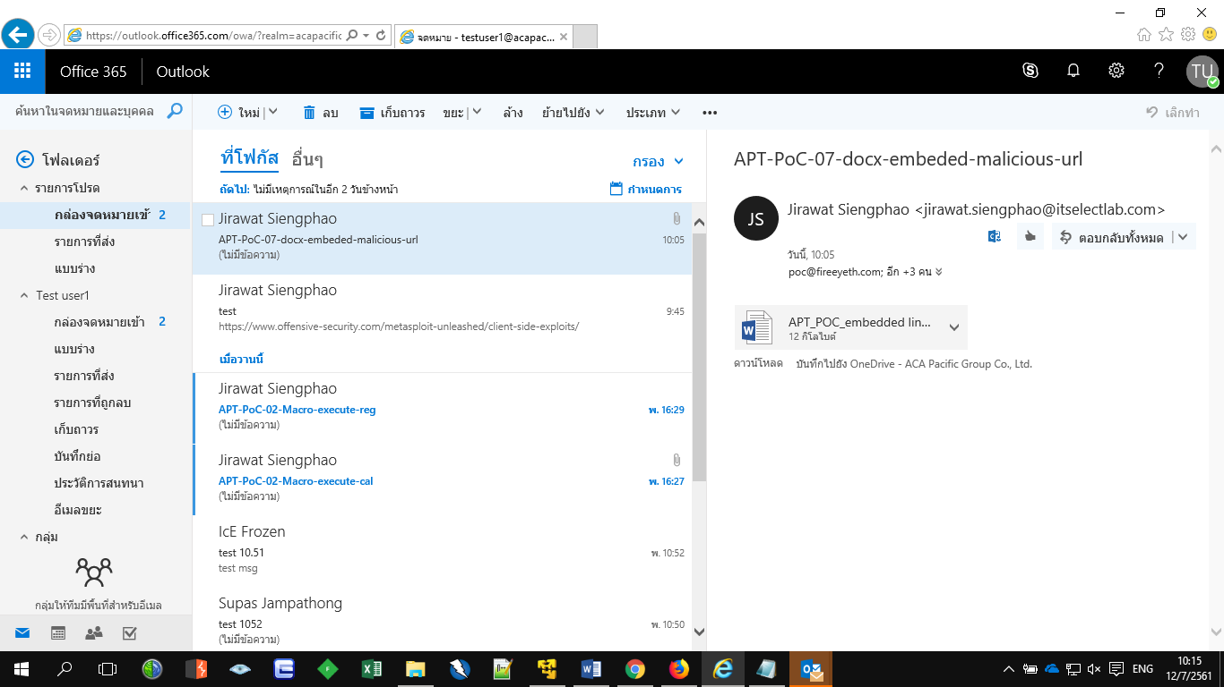

# Forcepoint

## 03 excel

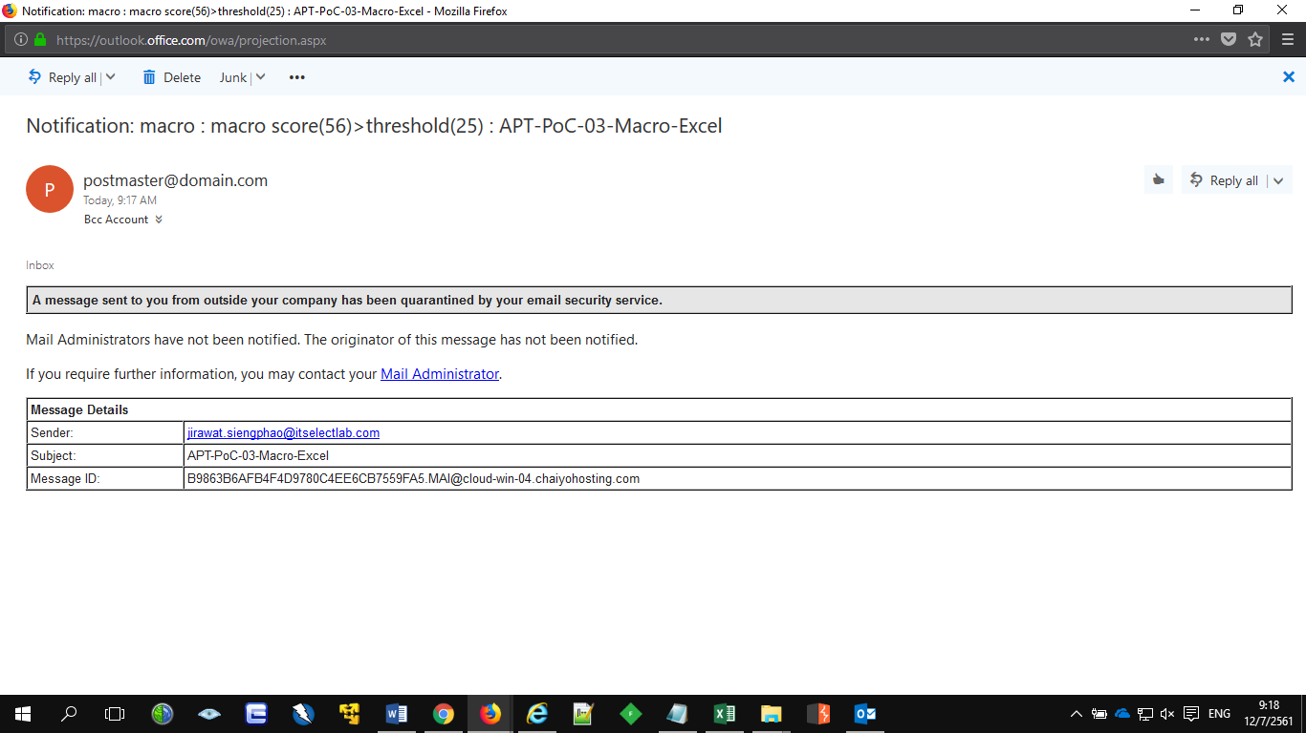

## 04 Known

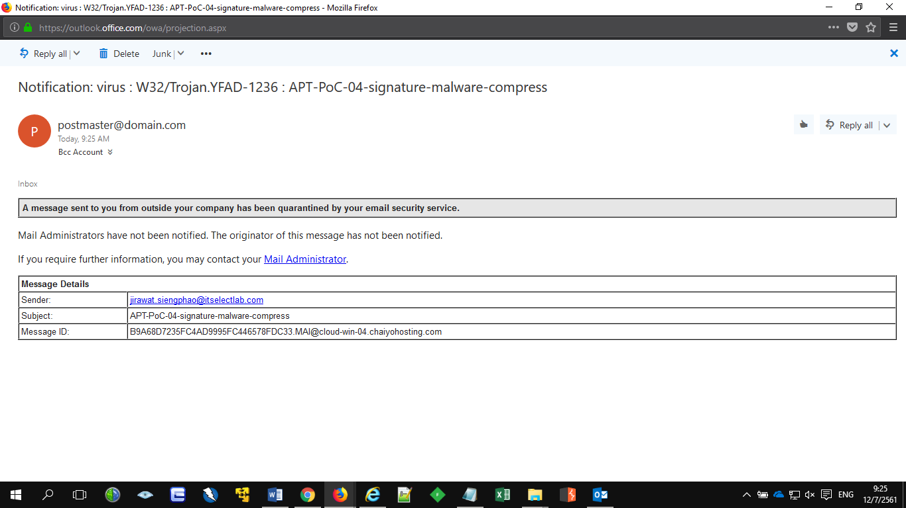

## 05 easy

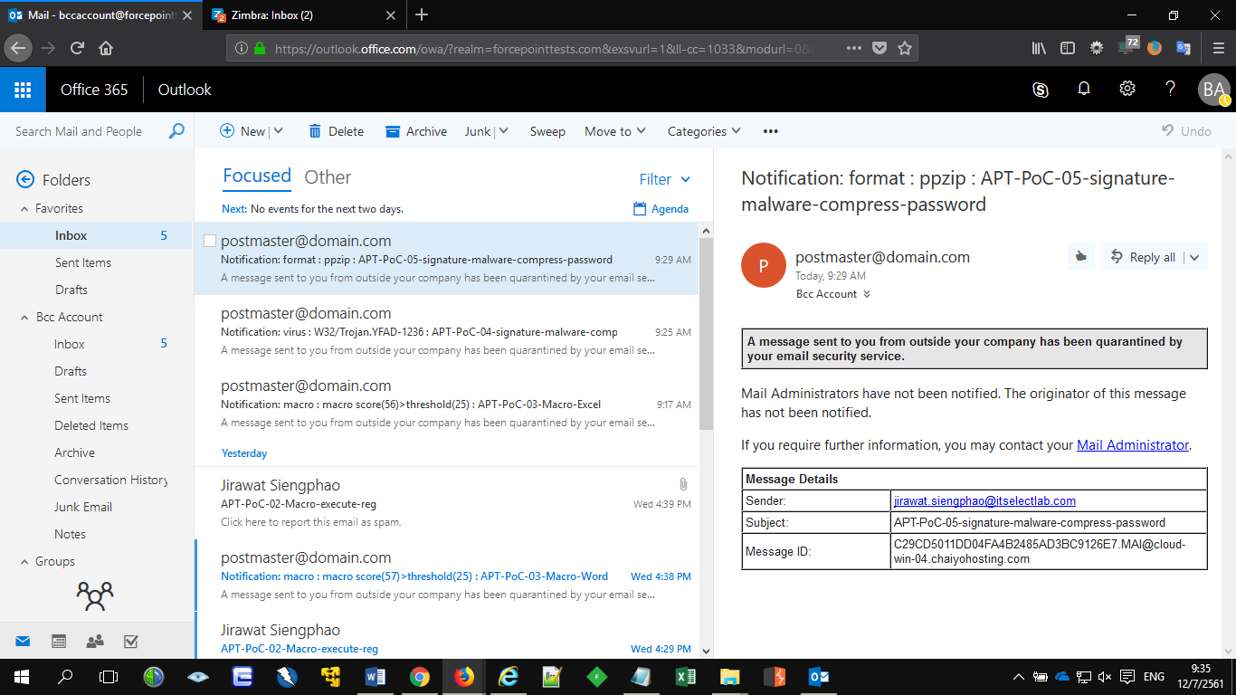

## 05 hard

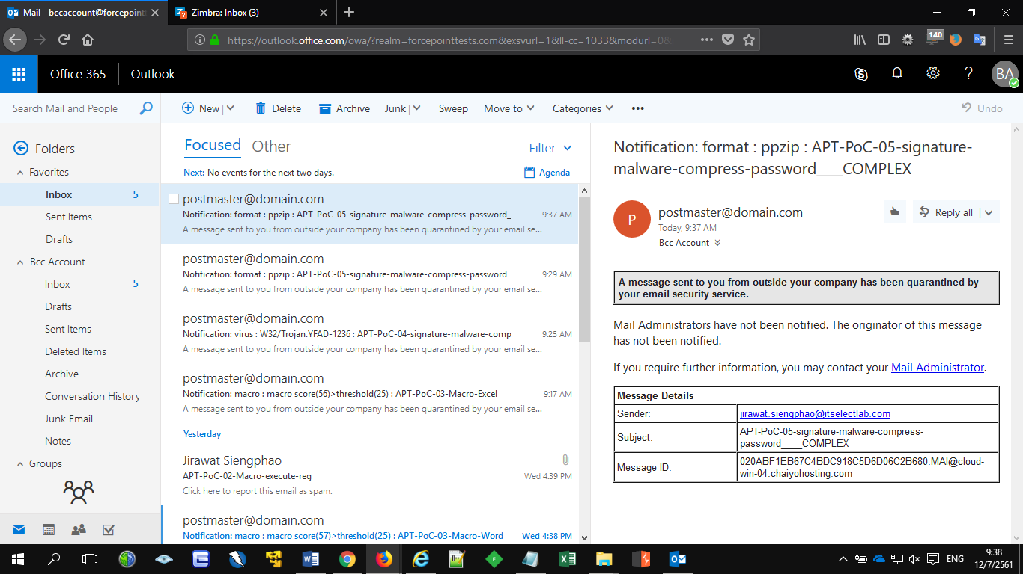

## 06 Clicktime

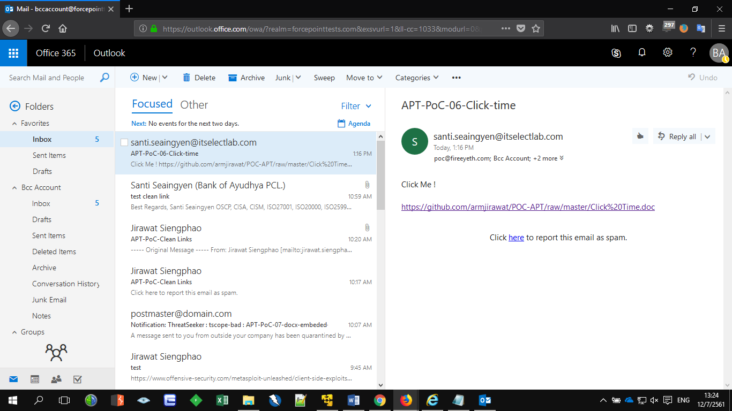

## 07 docx

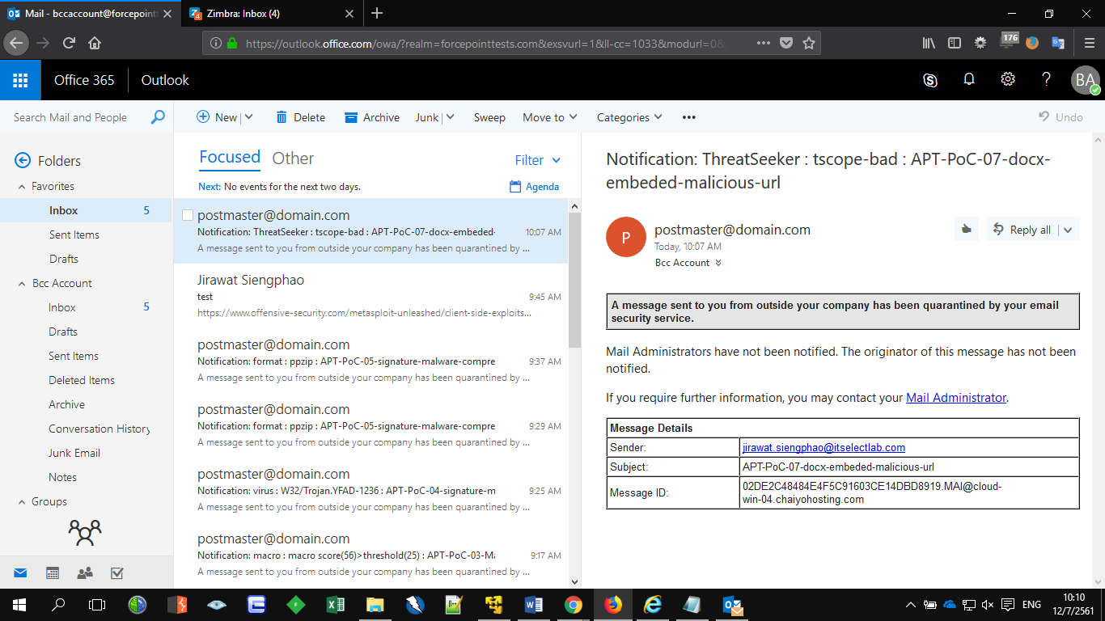

# FireEye

## 03 excel

Quarantined

## 04 Known

Quarantined

## 05 easy

Quarantined

## 05 hard

Quarantined

## 07 docx

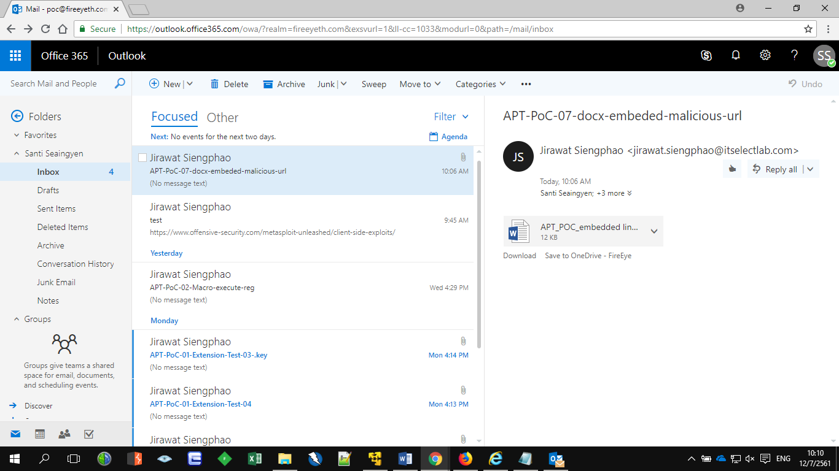

## 06 Clicktime

